Spread operator performs shallow copy.

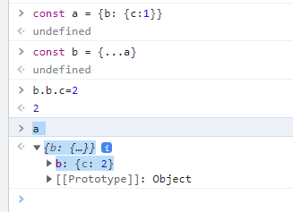

For deepcopy we need libraries such as lodash or implement deepcopy function on our own